(3 Point) You have main function which is saved on folder named Q3 already. Use these classes and functions to test all your operations in this question, DO NOT EDIT ANY CODE in main function. You can add more operations/classes/interfaces to be able to answer the below question.

Design and code a class named Student that holds information of a Student, including:
- A string describes name of a student as formatting of “last name middle name and first name”, example David Neo Akanra.
- A string describes id of a student.
- A whole number describes semester of a student.
Include the following member functions in your design:
- Constructors to set values for instance variables.
- Add needed operations to the class and complete below method which is declared in Student class, the function will be used in the second test case.
- String getStudentCode() – this function return value of student code as format of firstname+first character of last name +first character of middle name + studdent id. Please note that there is no empty characters among characters of StudentCode.

The program output might look something like:

No of test case | Correct output
2 | 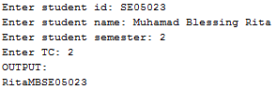
1 | 